1. Which are the top three variables in your model which contribute most towards the probability of a lead getting converted?
   1. Lead_Source_Welingak Website 2.508447
   2. Occupation_Working Professional 2.333358
   3. Lead_Origin_Lead Add Form 2.289549

1. What are the top 3 categorical/dummy variables in the model which should be focused the most on in order to increase the probability of lead conversion?
   1. Lead_Source_Welingak Website 2.508447
   2. Occupation_Working Professional 2.333358
   3. Lead_Origin_Lead Add Form 2.289549
2. X Education has a period of 2 months every year during which they hire some interns. The sales team, in particular, has around 10 interns allotted to them. So during this phase, they wish to make the lead conversion more aggressive. So they want almost all of the potential leads (i.e. the customers who have been predicted as 1 by the model) to be converted and hence, want to make phone calls to as much of such people as possible. Suggest a good strategy they should employ at this stage.
   1. We need to concentrate on the leads from Welingak Website as the coefficient is high and we have potential leads.
   2. If the occupation is working professional, we need to concentrate on these leads and try to convert them.
   3. If the lead origin is from Lead Add form , we need to contact them as early as possible , as they are a potential leads as per our model.
   4. If the last notable activity is not reachable or SMS sent we can contact them as they can be a hot lead.
   5. In the model defined, we can contact all the leads where the hot leads are defined as lead score greater than 78 %. As they can be hot leads.

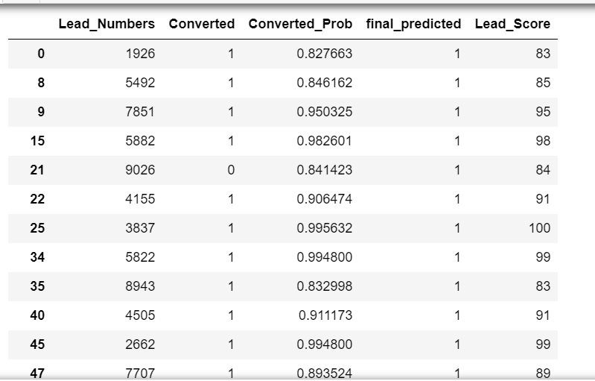

1. Similarly, at times, the company reaches its target a quarter before the deadline. During this time, the company wants the sales team to focus on some new work as well. So during this time, the company’s aim is to not make phone calls unless it’s extremely necessary, i.e. they want to minimize the rate of useless phone calls. Suggest a strategy they should employ at this stage.
   1. We need to concentrate on all the criteria with positive coefficients as mentioned below.
      1. Lead_Source_Welingak Website 2.508447
      2. Occupation_Working Professional 2.333358
      3. Lead_Origin_Lead Add Form 2.289549
      4. Last_Notable_Activity_Unreachable 2.034160
      5. Last_Notable_Activity_SMS Sent 1.395211
      6. Time_on_Website 1.055896
   2. Contact the leads from welinkage website, if the occupation is working professional, the lead originated from the Lead add form.
   3. Need to contact if the last activity is SMS sent if the Time spent on the website is more.
   4. Also if the Lead source is from Google, occupation is other, if its do not email, the source is from direct traffic we need not contact them as the coefficients are negative.
   5. We need to concentrate on the hot leads depending on the lead score as mentioned in the model development, as the model parameters are good.
   6. We can also try to get positive feedback from the existing learners, try targeting newsletters, personalized emails, giving some discounts and increasing the advertising.